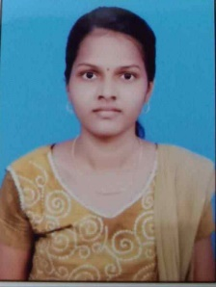

kavitha S

Computer science & engineering

|  |  |
| --- | --- |
|  | **Objective** |

Seeking a challenge avenue where my potential match the growth and for the better of your concern and also to enrich my knowledge with rich technical skills.

|  |  |
| --- | --- |
|  | Education |

## Agni college of Technology | College

## Rani Lady Meyyammai Hr. Sec| School

**Higher Secondary**

### 2020

STATE BOARD 12th – 82.33%

## Rani Lady Meyyammai Hr. Sec | School

**SSLC**

### 2018

STATE BOARD 10th – 93.8%

|  |  |
| --- | --- |
|  | LANGUAGES |

|  |  |
| --- | --- |
| ENGLISH - Full Professional Proficiency  TAMIL - Full Professional Proficiency |  |

|  |  |
| --- | --- |
|  | Skills |

|  |  |
| --- | --- |
| * JAVA * HTML * CSS * Problem Solving * PYTHON * GOOD COMMUNICATION |  |

|  |  |
| --- | --- |
|  | Contact details |

* Contact : 6382912816
* Linkedin : https:/www.linkedin.com/in/kavitha-sankar-917441230
* Email Address : kavithasankar1633@gmail.com

|  |  |
| --- | --- |
|  | PERSONAL details |

* DOB :21/04/2003
* D/O : Sankar S
* Address : No-1633 ,5th Cross Street, Kannagi nagar,Okkiyam thuraipakkam , Chennai - 600097